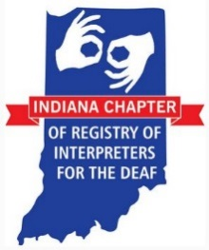
Indiana Chapter of Registry of Interpreters for the Deaf (ICRID)
“People, Purpose, Passion”
September 23, 2017

Name of Organization:__________________________________________________
Contact Person:__________________________________________
Address: ________________________________ City_________________
State:___________ Zip:___________
Email: ______________________________________________
Phone Number: ____________________________

Amount: _________

Make Checks Payable to ICRID
To pay online visit: www.icrid.org/sponsors

Mail To: Email to:
ICRID c/o Annual Conference Chair OR vicepresident@icrid.org
1126 N. Edmondson Ave
Indianapolis, IN 46219

