ICRID’s Checklist for Hosting an Approved Sponsor Activity
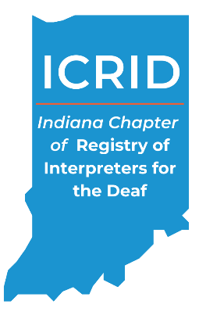
Title of Workshop: _______________________________________________________
Provide at least 45 days BEFORE event:
- Continuing Education Activity Plan Instructor’s Form
- Continuing Education Activity Plan Sponsor’s Form
- Instructor(s) Bio, Resume, or Vitae
- Educational Agenda/Handouts
- Promotional Materials (brochure, flyer, registration form, etc.) All promotional materials must include:
- The RID CMP and ACET logo
- The following paragraph: “ICRID is an Approved RID CMP Sponsor for continuing education activities. This (Professional or General) Studies program is offered for (#) CEUs at the (Little/No, Some, Extensive, or Teaching) Content Knowledge Level.”
- Information on the educational objectives of the activity.
- Information on the refund and cancellation policy or a link to this information on a website.
- Target audience – as described in the Continuing Education Activity Plan Instructor’s Form.
- A Statement soliciting requests for reasonable accommodations from potential participants
- A statement identifying policies on non-discrimination and promoting an environment of mutual respect and free from bias.
The ICRID CMP will let you know when your activity is approved and provide you with an Activity Number and an RID Course ID.
If you would like your activity to be listed on the ICRID website please send the promotional material you’d like displayed to webmaster@icrid.org

Provide within 30 days of the event completion:
- Activity Report Form that was provided to you by the CMP
- Evaluation Summary (including comments)
- Blank Certificate of Attendance (if you used your own)

